A brief guide on how to run a trace

I’ve written this specifically using problems with the MI save as an example, but it’s applicable to most things causing a problem in Flocase.

1. In SQL Server Management Studio, select SQL Server Profiler from the Tools menu:

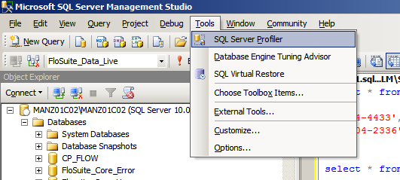

2. On the next screen, make sure you’re connecting to MANZ01C02\MANZ01C02 (for problems on Flosuite_Data_Live. For Dev enter MANDEVSQL) and press Connect:

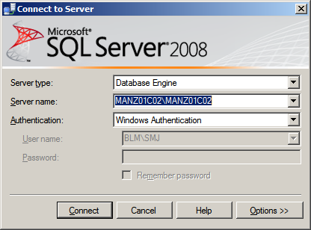

3. On the next screen, select TSQL from ‘Use the template’ drop-down:
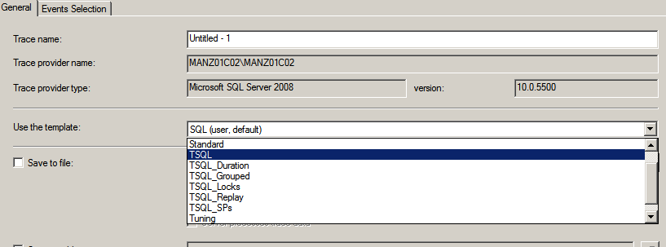
4. Go to the ‘Events Selection’ tab and untick all the boxes apart from the last one:

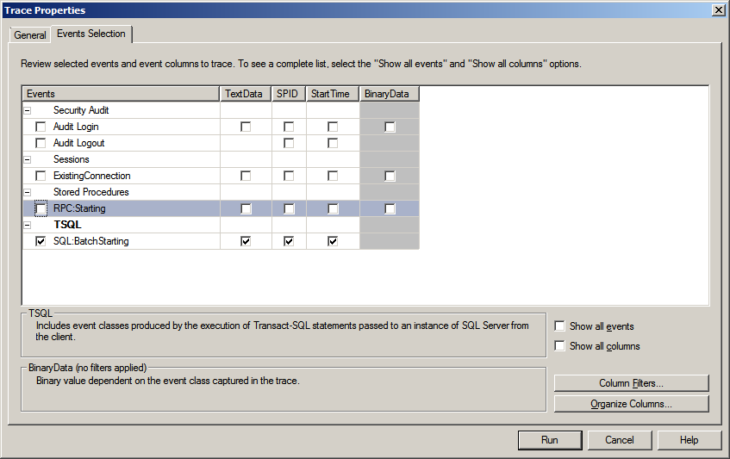

5. Tick the ‘Show all columns’ box:

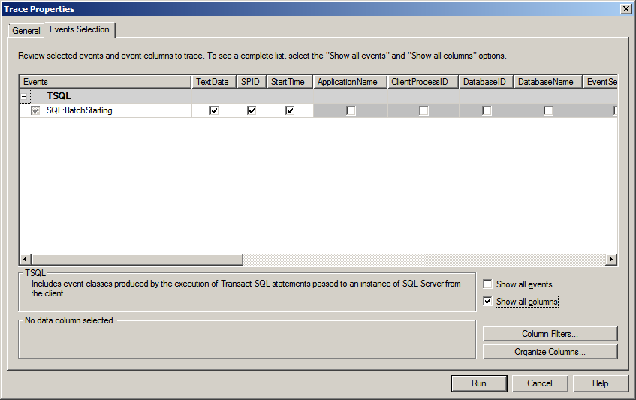

6. Press the ‘Column Filters’ button, highlight ‘DatabaseID’, expand ‘Equals’ and enter 15. (This is the DB ID for Live, The Database ID for Flosuite_Data_Dev is 13. For any other DB, go into the DB, bring up a new query window and type ‘select db_id()’)

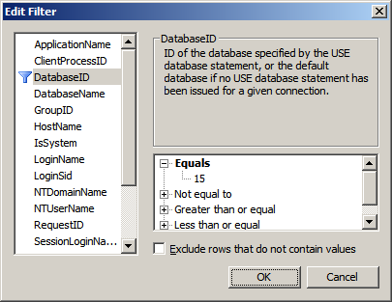

7. OK that and press Run to start the trace once you press Save (or just before the user presses it). Stop the trace after a few seconds. Look for the line EXEC [ClientMiFieldSet_ProcessForSave]…. (You can also search for it by going to Edit-Find). Select and copy the text in red in the bottom window:
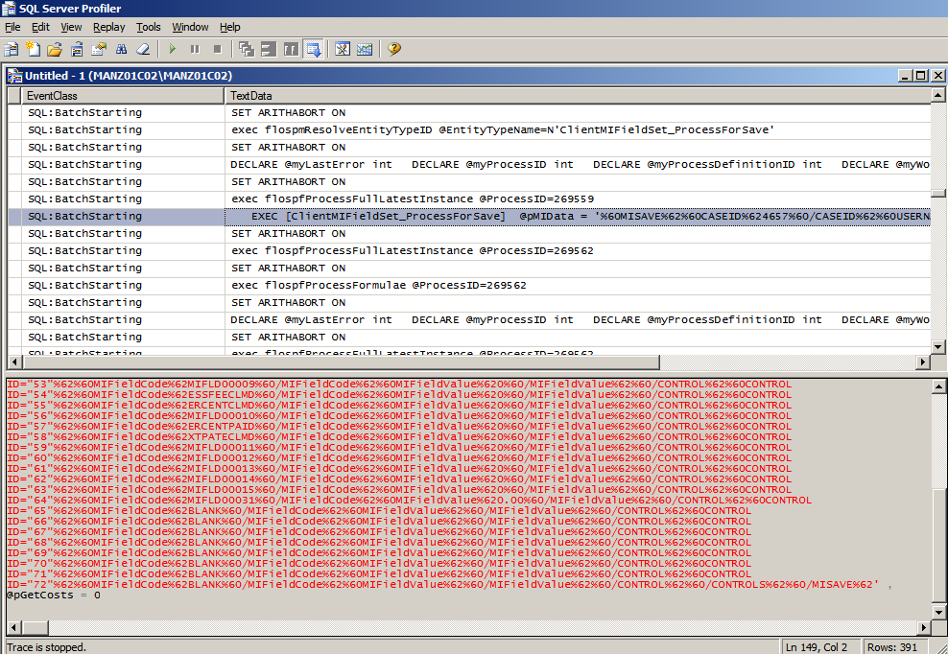
8. Go to SSMS, Flosuite_Data_Live (or relevant DB), open a new query window, paste in what you just copied and execute it.

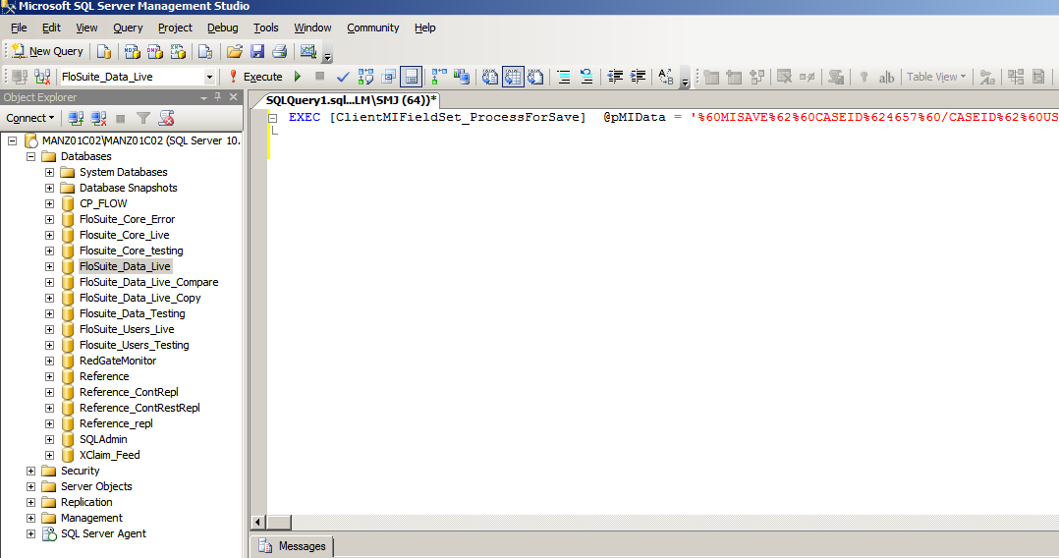

The message window at the bottom will tell you what the problem is.

Common problems (for MI) are:
Duplicate Case KeyDates
The MI set doesn’t exist for the Case Group Code
An incorrect data type has been entered in a field
There’s a duplicate MI Field Definition code
There’s a problem with one of the calculations
A field doesn’t exist in a table
A stored procedure is missing a parameter

It’s usually a duplicate CaseKeyDate, which you can remove by running the following:
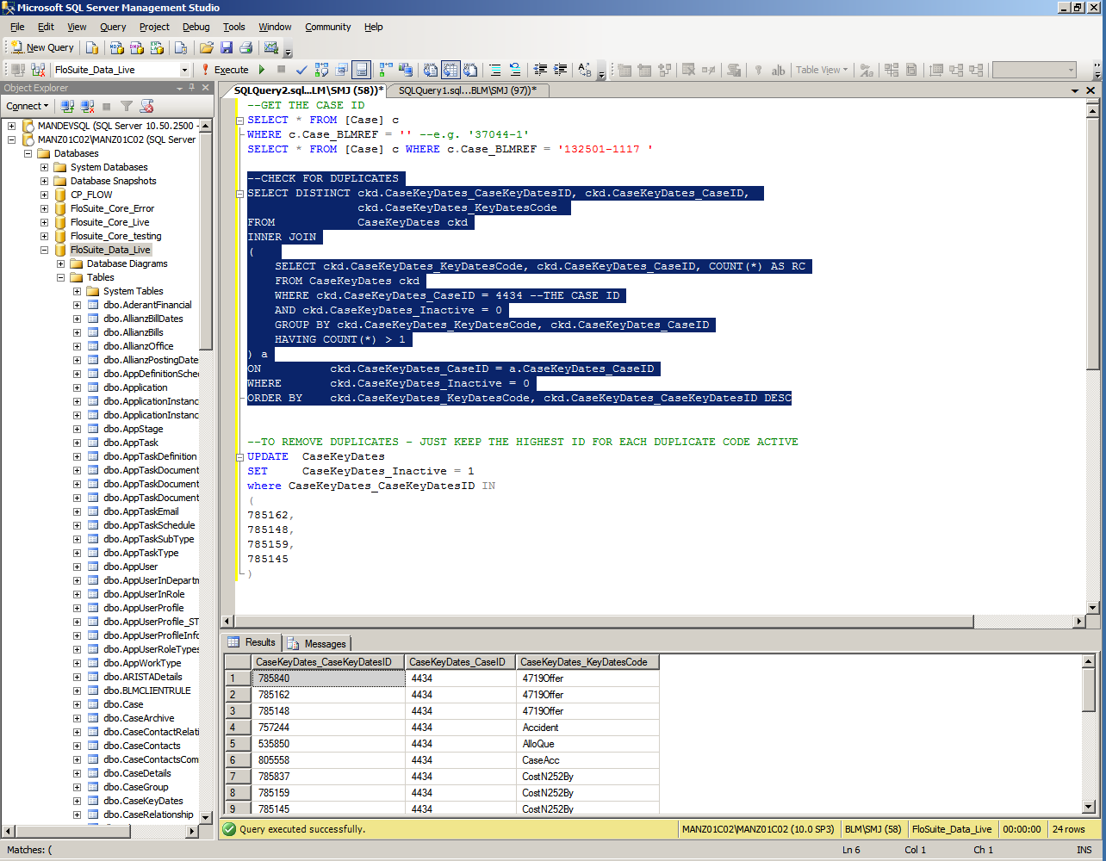

Here’s the actual code:

--GET THE CASE ID
SELECT * FROM [Case] c WHERE c.Case_BLMREF = '132501-1117' --REPLACE WITH THE ACTUAL REF

--CHECK FOR DUPLICATES
SELECT DISTINCT ckd.CaseKeyDates_CaseKeyDatesID, ckd.CaseKeyDates_CaseID,
ckd.CaseKeyDates_KeyDatesCode
FROM CaseKeyDates ckd
INNER JOIN
(
SELECT ckd.CaseKeyDates_KeyDatesCode, ckd.CaseKeyDates_CaseID, COUNT(*) AS RC
FROM CaseKeyDates ckd
WHERE ckd.CaseKeyDates_CaseID = 4434 --REPLACE WITH ACTUAL CASE ID
AND ckd.CaseKeyDates_Inactive = 0
GROUP BY ckd.CaseKeyDates_KeyDatesCode, ckd.CaseKeyDates_CaseID
HAVING COUNT(*) > 1
) a
ON ckd.CaseKeyDates_CaseID = a.CaseKeyDates_CaseID
WHERE ckd.CaseKeyDates_Inactive = 0
ORDER BY ckd.CaseKeyDates_KeyDatesCode, ckd.CaseKeyDates_CaseKeyDatesID DESC

--TO REMOVE DUPLICATES - JUST KEEP THE HIGHEST ID FOR EACH DUPLICATE CODE ACTIVE
UPDATE CaseKeyDates
SET CaseKeyDates_Inactive = 1
WHERE CaseKeyDates_CaseKeyDatesID IN
(
785162,
785148,
785159,
785145
)

I’ll write a separate guide to show you how you can resolve the other problems as they’re more complicated, but at least you’ll be able to determine what’s causing the problem(s).

/tmp/lo/0000.doc

